UNIVERSITY OF MAINE SYSTEM
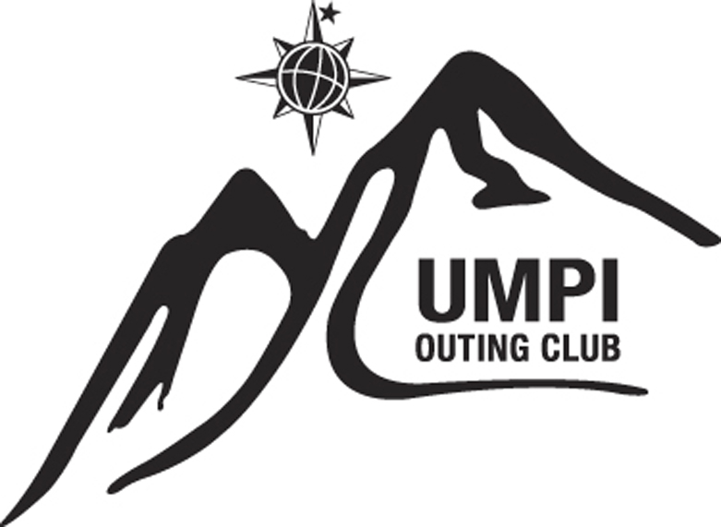
UNIVERSITY OF MAINE AT PRESQUE ISLE
UMPI Outing Club
Release and Assumption of Risk
(Adult)

(Please print all information clearly and read both sides. Signatures required on reverse side)

Name:___________________________________________ Date of Birth:______________ Age:_____

____________________________________________________________________________________
Street Address City State/Province Zip/Postal Code

Phone#__________________ or________________ Email Address: _____________________________

Emergency Contact Person:____________________________ Phone # ______________or ___________

I, the above named individual acknowledge, declare and agree as follows:

- That I have voluntarily agreed to participate in the ____________________________________________,
“Program” or Trip
from _______________________________________________________
Month Day Year

at the University of Maine at Presque Isle (University) and in consideration of being permitted to participate in this Program, do voluntarily execute this “Release and Assumption of Risk” on behalf of myself, my heirs and next-of-kin, my personal representatives and my estate.

- That I have been fully informed of the nature, scope and demands of this Program, and I understand that such participation may include activities which could be dangerous to me and other participants and which could cause property damage, bodily injury and/or death. Such dangers, hazards and risks of this activity may include, but are not limited to:

Abdominal pain, abrasions, allergic reactions to stings or food, anaphylactic shock due to allergic reaction, animal bites, bleeding due to puncture wound, cut, or scrape, blisters, shortness of breath, burns due to exposure to the sun, or contact with a hot surface, chest injuries due to a fall or traumatic blunt hit, constipation, diabetic emergency, diarrhea, dislocations, eye injuries related to thermal burns, chemical burns, entanglements, foreign or impaled objects in the eye or other body part, fainting due to light headedness resulting from increased heart rate, increased blood pressure, fractures, frostbite, giardia, head injuries including concussion, brain injuries, and skull fractures, heat illnesses including heat cramps, heat exhaustion and heat stroke, hypothermia, hyperventilation, immersion foot, trench foot, impaled objects, infections, insect and spider bites, joint swelling and inflammation, muscle swelling and inflammation, nosebleeds, poisoning and toxic substance inhalation, poison ivy, poison oak and poison sumac, rashes, seizures, shock, snake bites, spinal injuries, sprains, strains, tendonitis, and tick bites.

- That the University has informed me that there may be dangers and hazards inherent to participants in this Program because of the activities involved, and that I personally recognize and appreciate that such dangers and hazards exist. I accept and assume full responsibility for all harm and injury, of every nature, including death, which may occur to me or which I may suffer or cause to others and for all damages or loss to any personal property owned by me or damaged by me, while I am participating in this Program and during all travel and transportation. I agree to indemnify, hold harmless and release the University, the University of Maine System and its Trustees, faculty, employees, volunteers and agents from and against any and all claims, demands, actions or causes of action, on account of damage or loss to my personal property, my personal injury or death, or the bodily injury, death or damage to personal property of others caused by me, which occur or result directly of indirectly from my participation in this Program, INCLUDING, BUT NOT LIMITED TO, ANY AND ALL CLAIMS, DAMAGES, DEMANDS ACTIONS OR CAUSE OF ACTION RESULTING FROM THE NEGLIGENCE OF THE UNIVERSITY, ITS TRUSTEES, FACULTY, AGENTS, EMPLOYEES OR VOLUNTEERS.

- I understand that before I start any exercise program, I should consult with a physician. I declare that I am able to physically withstand and cope with the indicated rigors of the activities at this Program with or without a reasonable accommodation. If an accommodation is needed, I will contact Program staff.

- I understand that the UMPI Outing Club has a zero drug and alcohol tolerance policy. The use, consumption, and possession of illegal drugs, alcohol, tobacco or other paraphernalia of ANY kind is strictly prohibited. Violation of this policy or behavior that indicates a breach of this policy may result in, but is not limited to removal from the program. Removal from the program may result in an evacuation charge for which I am responsible to pay.

- This “Release and Assumption of Risk” shall be construed and interpreted pursuant to the laws of the State of Maine, and if any portion thereof is held invalid, unenforceable or illegal, the remainder shall continue in full force and effect.

I declare that I completely understand and have fully informed myself of the terms and conditions of this “Release and Assumption of Risk” by having read it, or having it read to me, before signing and I intend to be fully bound thereby. This “Release and Assumption of Risk” shall remain in effect during the term of the Program. I acknowledge and accept responsibility for my personal actions. I understand and accept that failure to comply with the Program safety policies and procedures may result in dismissal from this Program.

_____________________________________________Assented and agreed to: ____/____/____
Signature of Participant (must be 18 years of age or older) Month Day Year

Media Release Form
In consideration of having my image, voice, and/or biographical material used and/or published, I _____________________________, for myself, my heirs and assigns, hereby grant and authorize the University of Maine System (“UMS”) the right to use, license or assign my image, voice and/or biographical material to publicize same as record, photographed, taped and/or filmed for use in informational or promotional materials published by or on behalf of UMS or any of its constituent parts or affiliates in photographic, print, video, electronic, digital or any other medium now known or that may be invented in the future, without limitation, (hereinafter all of which are included in the term “Material”) and to do so with or without mention of my name.

UMS shall have complete ownership of the Material and shall have exclusive right to license and use the Material as UMS wishes, including, but not limited to, the rights of copying, performance, display, reproduction and distribution in all media, and the right to create, perform, display and distribute derivative works of Material.

I agree to indemnify and hold UMS harmless from and against any and all claims, damages and expenses that UMS may become liable to pay arising out of or caused by any matter or material furnished or spoken by me in connection with my appearance.

I hereby release UMS, it employees and agents, from all claims, damages and expenses incurred by me arising out of or in connection with my appearance and/or the use of the Material, except to the extent that those claims, damages and expenses are the direct result of the negligence of UMS.

I request that this Release be construed and interpreted pursuant to the laws of the State of Maine, and if any portion thereof is held invalid, I request the remainder continue in full force and effect. I declare that I completely understand and have fully informed myself of the terms and conditions of this Release by having read it, or having it read to me, before signing.

_______________________________________________ _________________________
Name Date

